WCF Service Application for svc

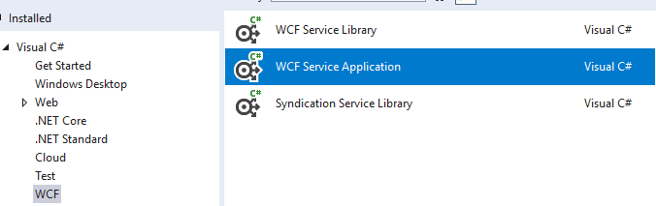

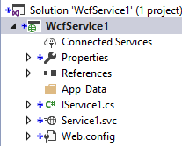

You may delete IService1.cs and Service1.svc

For ASMX

* No borre archivos IService ni Service.svc
* agregue archive Nuevo WCF ASMX

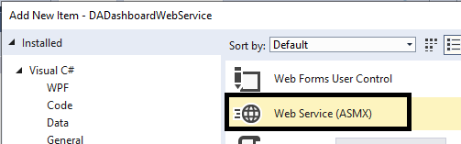

TestCalc.asmx

using System;

using System.Web;

using System.Web.Services;

namespace Test

{

[WebService(Namespace = "http://tempuri.org/")]

[WebServiceBinding(ConformsTo = WsiProfiles.BasicProfile1_1)]

[System.ComponentModel.ToolboxItem(false)]

public class TestCalc : System.Web.Services.WebService

{

private RPAAdapter db = new RPAAdapter();

**[WebMethod]**

public int calc(int parm)

{

return param*10;

}

**[WebMethod]**

public string STAT(string robotName, string Data01)

{

string message = "";

try

{

db.upSet_DA_Dashboard_Insert(robotName, Data01);

}

catch (Exception e)

{

if (e.InnerException != null)

message = e.InnerException.Message;

else

message = e.Message;

}

return message;

}

}

}

Corralo y aparecera en pantalla

<http://localhost:65022/test2.asmx>

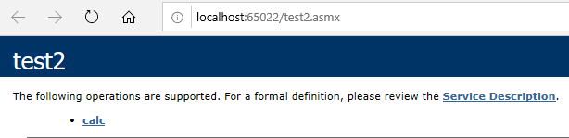

PUEDE INVOCARLO Y PASAR PARAMETROS Y VER RESULTADO

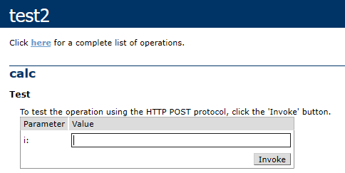

<?xml version="1.0" encoding="ISO-8859-1"?>

<int xmlns="**http://tempuri.org/**">**100**</int>

Luego publique como un svc

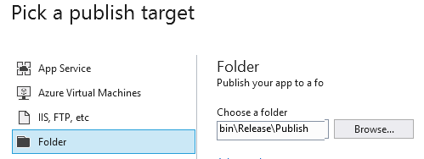

Test service

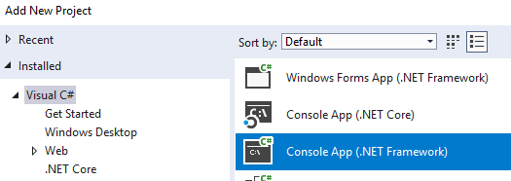



Discovery

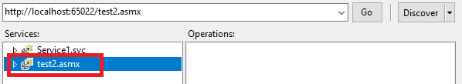

ServiceReference1.test2SoapClient ss = new ServiceReference1.test2SoapClient();

int i = ss.calc(10);

Publish

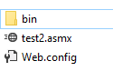

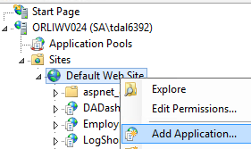

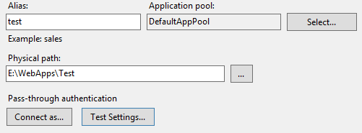

Call from app

<https://orliwv024.na.convergys.com/test/test2.asmx>

test as the alias in IIS

test2.asmx the web service file

ServiceReference2.test2SoapClient ss = new ServiceReference2.test2SoapClient();

int i = ss.calc(10);